# FAUX

Amish Kanji, Josh Radicchi, and Joel Gardyasz

### Dept. of Electrical Engineering and Computer Science, University of Central Florida, Orlando, Florida, 32816

### *Abstract* — The purpose of this project is to design and construct a tracking device that will allow a user to track down lost items in an indoor setting and to a certain extent outdoors as well. We utilized the advanced beacon technology to track down items using transmitted data packets to sense a signal. The project will also consist of a printed circuit board to add external lights and a buzzer to help the user track down the item efficiently. The paper presents the design methodology of creating all the subsystems of our project and integrating them together to form the complete tracking device.

### *Index Terms* — Estimote, iBeacon, beacon technology, microcontroller, Bluetooth Low Energy

### I. Introduction

This project, as described, is a tracking device that users will attach to their everyday valuables in order to acquire a greater sense of security for their possessions. Devices to track down valuables for users are already currently on the market but we designed our project to take the best aspects from the competitors and to add new technology that we believe advances the functionality of a simple item tracker. We also believe that not many people utilize the current tracking devices on the market today which also helps us believe that our project could be the turning point. Motivation for this project can definitely be accounted for from personal experience or similar experiences involving friends and/or family. There have been countless stories between our group members where either one of us, or someone we know, has lost an item and had bad results following due to the item being misplaced. Most people don’t have a means of locating a lost item other than trying to remember the last memory of using the lost item or where the item could have been misplaced. Both of these situations are subject to human error because in some instances, the certain individual could incorrectly remember the last place they believe they were before misplacing the item, which could culminate into a misleading search based on the incorrect memory. We want to take away the chance of human error and give everyone a means of being certain of the location/proximity of the lost item.

Losing items like your wallet or a laptop in today’s era could have catastrophic impacts on your life. For example, many people have everything from their job saved on their laptop and losing this might mean losing their job. Even though there are current items out there to help prevent this from happening, they have not been adopted by a majority of the general population. The lack of use of these items could be for numerous reasons but our project will attempt to finally have people invest in an item that will prevent common misplacements resulting in the waste of people’s time.

### II. System Components

This project is made of several subsystems that are best described in their own respective sections. Each of the subsystems has been either been chosen or designed to appropriately fit the overall system. We will discuss the unique attributes and features of each of the subsystems and explain why these components were chosen instead of others.

*A. iBeacon*

The first major design choice we had to make in our project was to determine what form of wireless communication we wanted to utilize for our project. After much research, we narrowed down the choices to three: Bluetooth (which consisted of the Bluetooth Low Energy and iBeacon protocols), Wi-Fi, and GPS/GSM. GPS and GSM were pretty much taken off of the table immediately because of the high battery consumption. Since our project has size requirements, our battery will be very small. If the communication will cause the battery to be drained at a high rate, this would not be ideal for a constant tracking device. Most projects currently use the Bluetooth Low Energy protocol to allow phones to sync up to devices as well as take advantage of the low battery consumption feature. In the end we chose to go with the iBeacon protocol for Bluetooth. Beacon technology is a class of Bluetooth Low Energy devices that broadcast their identifier to nearby portable electronic devices. Few current handheld tracking device utilizes this technology which gives our project a fairly unique attribute. The major advantage to using iBeacon is the elimination for the need to sync your phone to the device. Due to the fact that iBeacon devices are constantly transmitting data packets every second, all a phone has to do is interpret the data that the beacon is sending. This allows the user to track a lost item using any device, whether it belongs to them or not.

There are many companies that create beacons for all different types of projects and we had to decide which company we were going to purchase ours from. We decided to purchase beacons from a company called Estimote. They make two separate types of beacon, Estimote beacons and Estimote Sticker Beacons, and we chose to purchase Estimote Sticker Beacon.



Figure 1: Estimote Sticker Beacons

There were many factors that were taken into account when deciding which beacon would best suit our project. The sticker beacon is just 3 mm thick and a lot smaller and less bulky than the original beacons which is a major plus because our the size constraints for the project. Items that have Sticker beacons attached to them are called nearables. Stickers broadcast two separate packets, the original iBeacon packet and the nearable packet. Utilizing this nearable packet, we can tell if an object is in motion or not as well as figuring out how far away an object is from a portable electronic device.

Ranging how far a beacon is from a device is done by placing the beacon in one of three zones: Immediate, Near or Far. Depending on what zone the beacon is labeled in informs the user how far away they can expect their object to be.

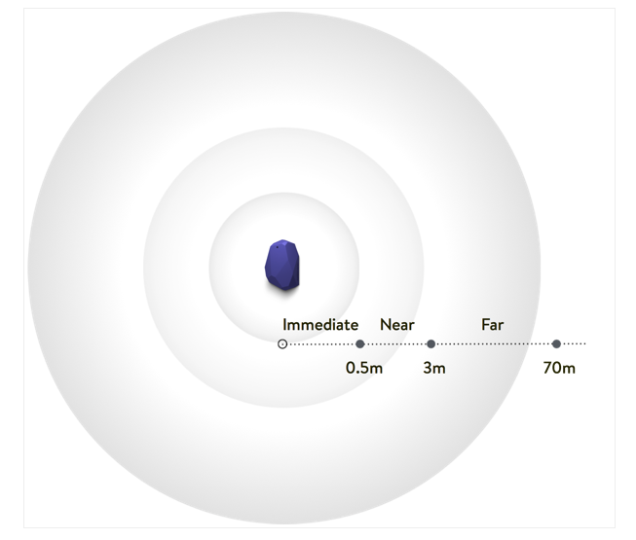

Figure 2: Ranging for Beacons

As Figure 2 shows, the three separate zones have distinct interval ranges which will allow the user to know the approximate distance away from the beacon. This picture illustrates zoning for an Estimote original beacon which is a little larger than the range of a Sticker beacon. The Sticker beacon can reach a theoretical max range of 50 feet which we decided is ample distance for our project.

Estimote also has its own developed SDK that makes it simple to access all of the features of their beacons as well as programming beacons to do certain tasks. This allowed us to import their software within our project with ease and to access all of their classes in our development environment.

*B. Microcontroller*

The microcontroller is the brains of this system. It controls all the other subsystems of this project. Given that size is very important to this project we want a microcontroller that is small but also powerful enough to run the whole PCB. Because of this we chose the Atmel ATmega 328P. It has 23 programmable I/O pins. It has 32kBytes of flash and 2kBytes of RAM. The microcontroller operates between 1.8 and 5.5 volts. You can see the pin layout in Figure 3. For the prototyping the Arduino Mega 328P is used in conjunction with Arduino IDE for programming. This proves to be a powerful tool as libraries can be used to help make controlling certain subsystems easier.

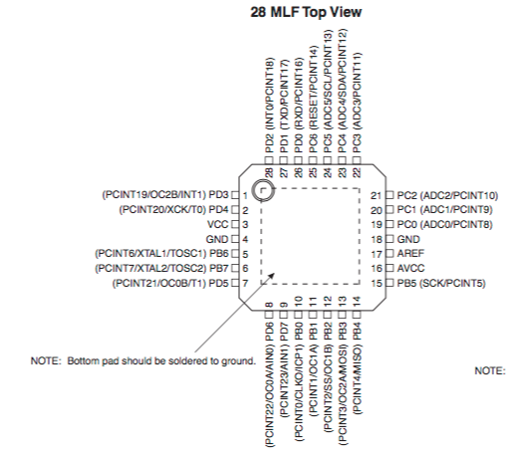

Figure 3: Microcontroller Pin Layout

*C. Bluetooth Module*

Our Project relies heavily on Bluetooth; we decided to use Bluetooth Low Energy (BLE) to communicate between our FAUX device and the application that we are building. The Bluetooth module that we chose is the LBM313-2540. Punch Through Design makes this Bluetooth module, and it has 2.4GHz BLE (Bluetooth 4.0) compliant. Punch Through Design isn’t a very big company, but the products that they make work very well.

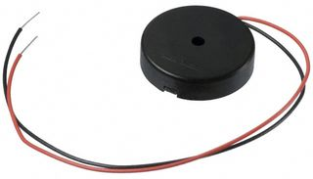This Bluetooth module has 46 different pins. It operates from 2 to 3.6 volts. This little module is 12mm by 16mm, If you don’t know how big that its, this chip is smaller than a dime. This module will control which and when a circuit will get voltage. As I mentioned before size is very important to this project. We do not want our device to be too large, that would make it harder for the user to effectively use this tracker. This is another reason that we chose this module; it is very small and fits perfectly on to our PCB design. Our PCB design can be seen in Figure 4.

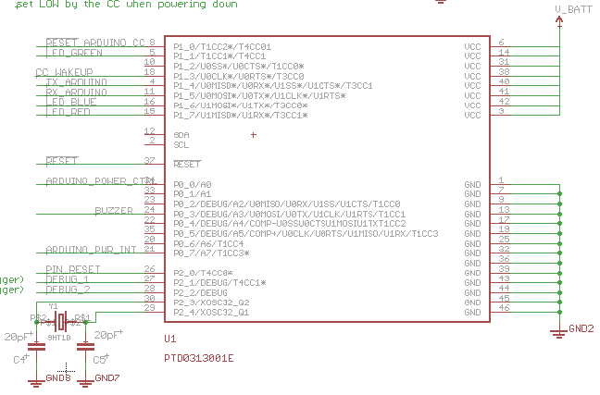

Figure 4: Bluetooth schematic

*D. Speaker*

Having a speaker, or piezo buzzer as it is formally called, allows the user to use their sense of hearing to help locate the lost device. This is extremely helpful when you know the approximate location of the device, but not the exact location. FAUX is designed to let the user know approximately how far away they are from the device, not necessarily where the device is exactly. Therefore, implementing a speaker onto the board was a must for the design and final implementation of this system.

The reasoning behind choosing use a piezo buzzer instead of a standard magnetic speaker was because of the size and power constraints on the system. When researching speakers used in electronic devices, we came across what is known as the Piezo speaker.  These speakers differ from the standard magnetic speaker in that they do not require a magnet to operate.  Piezoelectric speakers are very easy to drive compared to other speaker designs; they use materials that demonstrate the piezoelectric effect to generate sound.  When an electric charge is applied to the material, the material will produce an internal mechanical strain, of which can be used to output a sound.  These speakers usually cannot produce a wide range of sounds from the audile spectrum, but they can produce a certain sound very loudly and with little effort to do so.  These types of speakers are generally used as beepers in electronic devices such as watches or pagers.  They are also resistant to overloads that could destroy other high frequency drivers.  That is why this type of device integrated perfectly into our designs and turned out to be exactly what we were looking for.

Figure 5: Piezo buzzer

*E. Miscellaneous Components*

In our project we also use other small components, we are integrating a buzzer and a LED into our PCB. These will have their own circuits that connect directly to the LBM313-2540 Bluetooth module. They are connected this way so you will be able to toggle the whether the buzzer or LED will be on. You will be able to control these components from the mobile application that we have created. These individual circuits can be seen in Figure 5. They each are connected separately to different pins of our Bluetooth module.

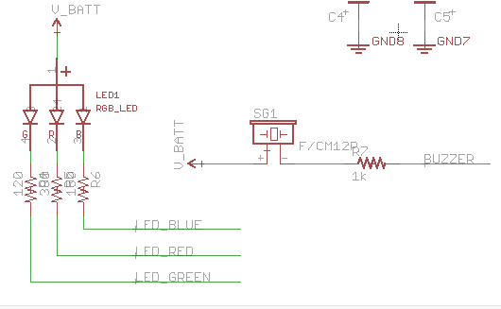

Figure 6: LED and buzzer circuit

### III. Prototype build

We need to take into account all of the components integrated together when constructing our project. The following sections will address the prototyping of our project and all of the issues that have and can occur during this process.

*A. Mobile Application Design*

When designing our mobile application, the first design decision we had to choose was which platform we were going to develop the app for. We were deciding between the iOS platform and Android and we decided to develop an iOS app mainly because we did not have an Android device readily available. As a group of three, we all have iPhones, MacBooks and some iPads but not any Android devices so it was practical for us to design an iOS app. The developing environment being used for this project is Xcode. Xcode allows us to create iOS applications with ease as well as friendly user interfaces. This environment also allowed us to import all of our third party libraries with ease to utilize them in our project.

Our application will have multiple components and features within the application. The main feature is to, of course, track down the item. This will be done utilizing the ranging feature of the beacon as was previously discussed in the paper. In order to explain how the tracking functionality will be accomplished, a flowchart has been created to follow the logic.

In order to track the object, FAUX must be able to sense a signal from the beacon. If no signal is sensed then we must inform the user that FAUX is out of range and that they should try and get closer to the last known location of FAUX. If a signal is detected, depending on the range interval, we need to return the appropriate zone to the user so they know what to do next. For example, if the application returns the “Immediate” zone, the user knows that the object should be extremely close to them and they know to look around them, but if the “Far” zone is returned, the user should know that they need to cover some more distance in order to reduce the interval gap. A summary of this is shown in the flowchart.

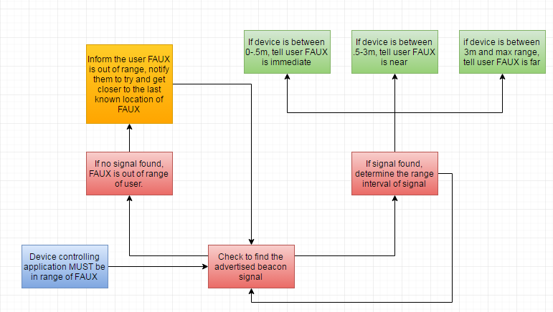

Figure 7: Tracking Functionality

We also had to include ways of utilizing our external components using our mobile application. As stated, we are utilizing a LED and a buzzer to help further help the user track down objects so we also needed to incorporate a way of allowing the user to use the LED and buzzer. We also need to include user-friendly messages in order to guide the user in the tracking process. Some users may not know what to do when a given zone is returned so we must pair the zone with a message informing the user what actions they should take next depending on the returned zone.

*B. PCB*

A single PCB was created in this project. The fine folks at Osh Park, where the PCB was made, did a remarkable job. Since no one in the group had any experience with Eagle software or with designing and populating a PCB, this became a challenge. Learning how to use the Eagle software is hard enough, but when you have to build and populate your own PCB it becomes very tricky. This PCB will be able to use BLE to communicate between the person’s smart phone or tablet and the FAUX tracking device.

As mentioned previously we want this board to be as small as it possibly could be. When creating the PCB schematic we had to make sure that we didn’t include excess parts that would make the board larger and heavier. Our PCB board layout had to be condensed as small as it possibly could be in order to fit everything in such a tiny space. The PCB board layout can be seen in Figure 7. This device is smaller than two quarters when they are put side by side. This is the perfect size for what we are trying to accomplish.

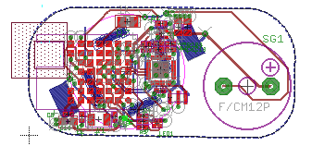

Figure 8: PCB layout

*C. Protective Casing*

To protect all of the circuitry we will have to house all of the hardware in a protective casing. We will be using Solid Works to cad our case. Once it has been finished we will use the 3D printers that are available on campus. The material that we plan on using to 3D print it is ABS plastic. We chose this over PLA plastic because it is much harder and much more durable.

The case will consist of two separate pieces that can snap together. We want the pieces to snap together so that way if the battery dies on it we would like the user to be able to easily replace it. The case also has to be quite thin in order for you to be able to hear the buzzer through it. It also has to be thin so you will be able to see the built in LED that we have on the board. We can’t make it too thin as to compromise the structural integrity of the case.

We also want this our device to be water resistant. This does not mean waterproof, we just don’t want our device to be destroyed if it is barely raining outside. This part will be tricky to do as we are not mechanical engineers, but it should be simple enough. The 3D image in Figure 7 shows how the two separate pieces of our case will snap together. We will also have a little hole at the top so that we are able to make it a keychain. Being that this will be 3D printed we could make the case customizable if the user wanted. This can act as a safety feature too if you wanted to get your phone number printed on your phone. This way if the owner loses their device the person who finds it will have a way to contact them and return their device to them.

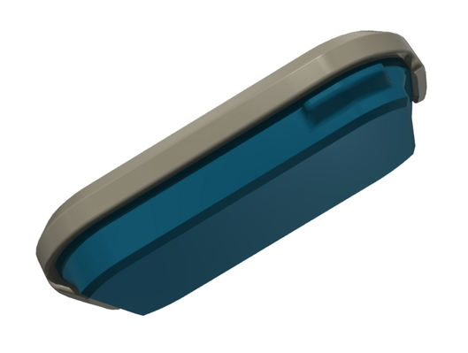

Figure 9: FAUX protective case

### IV. Testing

Testing the project was extremely important, as we needed to ensure that all of the components of the project were working accordingly. Unit testing was initially done to ensure all the components worked properly and then the system needed to be tested as a completed project.

*A. Mobile Application Testing*

In order to see if the mobile application was working properly, we needed to test the functionality of the beacons first. We needed to make sure that the application was returning the correct zone when sensing a beacon and that the correct zone was appropriately displayed to the user. We also needed to ensure that the application was able to sense a signal if a beacon is in range. This is the most important thing because nothing will occur if no signal is sensed.

The initial application testing was to see if we could sense when a device entered the range of a beacon. This was simply done by sending a push notification to the user when they enter the beacon saying that FAUX has been detected. We also decided to inform the user when they got out of range of the beacon as well. This could prevent the user from accidently forgetting or leaving their item behind.

Another feature we had to test was the zoning of the beacons. We had to ensure that our application was returning the appropriate beacon zone to the user when a beacon was tested. This was done by placing a beacon at random distances away from the device and seeing the zone appear on the screen as well as witnessing the zone change when the distance between the beacon and the device changes.

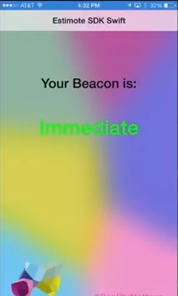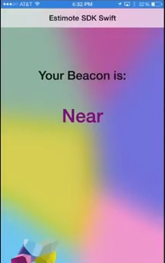

Figure 10 and 11: Mobile Application Prototype Screens

In the above screens, you can see that the zone is clearly labeled in the center of the screen and matched the distance between the beacon and the device during our test. Again to reiterate this is a simple mockup screen and is not the end product screen for our application. This test screen was created to simply test the zoning functionality of our beacons. The user interface will have to change for our end product to fit with our other desires. Recall that we also wanted to insert user-friendly messages for the different zones to aid users in determining what actions to take depending on the situation.

Some final features that we may implement depending on time constraints is testing the motion of FAUX. We believe that the motion state of FAUX is important as it can prevent theft if the user knows when the item’s state changes. We will attempt to notify the user when their object is in motion by sending them a simple push notification. This may as well reduce the chance an item is misplaced, stolen or forgotten. Our main functionality is to track down a lost item but preventing an item from being lost in the first place is equally as important for the project.

*B. Hardware Testing*

There is a good bit of hardware that we need to test in order for this project to work properly. The main component that we have to test is the PCB, but there are many different parts of the PCB that we need to test. There is the buzzer circuit, a LED circuit, the BLE that controls it, and the entire PCB as a whole. Each of these needs to be tested separately and then together to make sure it works successfully as a system. We have everything connected to the PCB, but we can still test the pieces separately.

The first we have tested is the LED. We tested this by connecting the 3-volt lithium ion battery. Without the Bluetooth module connected we can connect the voltage directly to the LED. Before we connected the LED we measured an output voltage of 718mV. This is equal to .7 volts, which is the turn on voltage for this diode. This graph is shown in Figure 10. Once we connected the LED it lit up which shows that it will work.

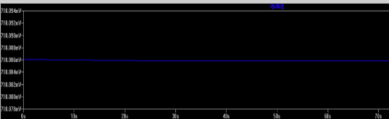

Figure 12: Output voltage of the LED

After that we tested the buzzer. We tested this the same way that we tested the LED. We tested this by connecting the 3-volt lithium ion battery. Without the Bluetooth module connected we can connect the voltage directly to the buzzer. Once it was connected the buzzer started to make a noise.

The next thing that we had to test was if and how the Bluetooth module controlled the power that went to the other circuits. The way to test this will be harder than the other circuits that we have to test. To test if the Bluetooth module actually works we will have to code it to turn the other circuits on and off. This will be the only way to make sure that the Bluetooth module works seamlessly in our circuitry.

The last thing that we will have to test is the PCB as a whole. We must make sure everything works properly. If everything doesn’t work correctly we can tweak the code. If everything works when it is separated it should have no problem when it is all working together.

*C. Indoor Testing*

Half the reason that we are making this device is so that if you are in a rush to get out the door our tracker will make finding your lost keys very easy. The way that we made this very easy is that we had a speaker and an LED attached on the inside of the FAUX tracker. The speaker will help you find the lost item in the daytime and the nighttime. The LED will mostly be helpful when it is dark in the environment that you are looking for your device. It would be easier to find FAUX in a dark room; this would be useful for two reasons. The first reason is that it helps you save money on electricity, given that it won’t be a substantial amount, but saving a small amount is better than not saving any. The second scenario is that if the power went out you would not be able to turn the lights on, but FAUX will still be very easy to find.

The first scenario we tested is that it is very early in the morning, and you are leaving for work, and you are trying to do so without waking anyone up in your home. Normally this would be easy, but today you misplaced your keys. Instead of going from room to room turning lights on and off in every room, flipping couch cushions, and anything else you do when you are frantically searching your house for something when you are running late. Instead of doing all of these things you could simply activate your FAUX tracker and listen where the sound is coming from, and see where the light from the LED is.

This is a very practical test scenario in which it utilizes all of the features that the FAUX tracker has to offer. The speaker makes it easy to hear what room your lost item is in, and the LED makes it easy to find your device when you reach that room. If you have the speaker on silent you would still be able to be guided to your lost item by the distance tracker that is on the iOS applications screen.

Another test scenario that we tested is if you are in a room and your lost device is on the complete opposite side of the house, would you be able to find FAUX even though there are many obstacles and walls in the way. We needed to know this Bluetooth range so when the customer is using the device he or she would not get frustrated that their FAUX tracker is not working. It will be interesting to find out how far away we could track our device from inside the house. We needed to make sure the distance readout that our iOS application gives will be accurate and not lead in the wrong direction.

*D. Outdoor Testing*

We also tested this device outdoors. This is where testing the tracking device starts to get much trickier. There are many more variables when we are testing the device outside. The largest variable is obviously the weather, especially in Florida where the weather can change from sunny to windy to down pouring and back to sunny all within one hour. In an ideal world our tracker would work as well outside as it does inside, but from experience we know that this is not the case. The weather takes a huge toll on the range of the Bluetooth.

The range was much better outside when it is sunny out as compared to when it is windy or rainy out. The first test scenario that tested is that you are exploring a new area that you have never been to before. You have been walking around for a while, then you decide to leave but you seem to have dropped your keys along the way. If you did not have your trusty FAUX tracking device attached to your keys you could spend a long time retracing your steps in order to find what you have lost.

If you have you FAUX tracker attached to your keys finding them would be much easier. All you would have to do is open up the application, and see how much distance is between you and the object that you have lost. Once you are close enough you will be able to turn on the speaker to use another one of your senses to guide you toward your lost item. If it were starting to get dark out when you start your search you would be able to activate the LEDs, which would make it very easy to spot once you are in range of it. We would need to perform this test in at least two different weather conditions; sunny to get when it has the ideal conditions, and windy or rainy to get the worst-case scenario. Both of these scenarios would still be better than not having any tracking device attached to your keys. If that was the case you could spend hours looking for your lost object instead of minutes. Since we live in Florida we also want to observe how FAUX behaves at the beach.

*E. Case Testing*

Testing the case of the device is very important because it holds all the important hardware that needs to be in working order for the device to operate properly. Because of this, we tested the case very thoroughly to make sure that there were no flaws in it design and to confirm that it would hold up to normal every day wear and tear. We dropped the case with the device inside of it a few times from varying heights in the range of one to a few feet from the ground. This would be about how far the device would fall if the user were to accidently drop it. Seeing as concrete would most likely be the roughest surface for the average person to drop the device on, this is what we performed our tests on.

*E. Final Testing*

The final testing involves integrating all of the subsystems into the final product. This test verifies that all of the systems are working correctly together. This test involves the normal operating conditions that the FAUX tracking device will be subjected to. We will have to perform tests in various environments, because when someone misplaces one of their items it is never in a proper place with proper weather conditions. It is crucial that we that we test indoors and outdoors. Once we have done that we can assure the user in what range it will work in the different environments.

### V. CONCLUSION

The main goal of this project is to create a portable, lightweight, and functional tracking system. After a long period of research and design, the group was able to put together and produce a product that consists of a device and a corresponding mobile application for that device. The device is to be kept with the belonging to be tracked, and the application used to locate the device. Breaking the project into multiple subsystems made it easy to work on separate subsystems simultaneously to streamline the building process. Building the printed circuit board with its many components could be implemented apart from the mobile application and microprocessor programming. Also, the casing for the device was able to be 3D printed as a separate subsystem and did not delay the building process. This allowed different members of the group to collaborate efficiently and work on each part of the project separately.

With every big project there will arise problems that will have to be dealt with.  This group has shown that it can work through any and all complications thrown at it.  This semester has proven to be great for us and the planning of our system.  The biggest problems that we ran into were deciding which parts to use for different components of the system.  This project has been an excellent experience for all members of the group for troubleshooting and problem solving in a real world design process.

### VI. BIOGRAPHIES

Josh Radicchi is a twenty-two year old Electrical Engineering student. Josh enjoys working on PCBs and also enjoys a good PB&J. Josh wishes to pursue a career in this field to design, implement and build PCBs.



Amish Kanji is a twenty-two year old Computer Engineering student. Amish wishes to pursue work in the cyber security field. He feels this project has taught him a lot about the life cycle of a system and hopes to use this experience in his future endeavors.



Joel Gardyasz is a twenty-two year old Computer Engineering student. Joel’s passion lies in computers, whether that is building them, coding on them, or simply using them. Joel has an interest in working in research and development for the defense industry. He has learned a ton from his four years at UCF and hopes to further his career in this field.